**A STATISTICAL STUDY ON TOTAL ENERGY PRODUCTION IN INDIA**

A PROJECT REPORT

Submitted in partial fulfillment of the

Requirement the Degree of B.Sc. in LIEU of

Paper of B.Sc. -3rd year Exam 2023-24

DEPARTMENT OF STATISTICS

KANORIA MAHILA MAHAVIDHALIYA

Supervised by:- Submitted by:-

**Dr. Rashmi Bundel**  **Saroj**

Assistant Professor ENRL. No.-20/42099

**CERTIFICATE**

This is to certify that Mr**. SAROJ**, a student of IV Semester, Enrollment No. 20/42099, pursuing B.Sc. in Statistics from the Kanoria PG College, University of Rajasthan, Jaipur, has successfully completed this project report titled “**A Statistical study on Total Energy Production in India”.** The report is based on secondary data and has been carried out under my supervision.

This project report is submitted in partial fulfillment of the requirements for the degree of B.Sc. in Statistics, in lieu of Part 3rd Examination 2022–23.

I further certify that this work is original and has not been submitted to any other university or institution for the award of any degree, diploma, or certificate.

**(Supervisor’s Signature)**

Dr. Rashmi Bundel

Assistant Professor

Department of Statistics,UoR

Date :

Place: Jaipur(Raj.)

**ACKNOWLEDGEMENT**

The place of pride in this galaxy belongs to my esteemed, **Dr. Rashmi Bundel**, for his engrossing guidance, propitious assistance, incessant encouragement and kind and gracious patronage during the entire course of investigation and preparation of this manuscript.

I also would like to extend my heartiest thanks to my seniors and colleagues.

With the humblest sense of regard and respect, I would like to thank my family for bearing with me during the course of project.

With deep reverence, I bow my head before the Almighty for they provide me with energy and path to pursue my dreams, specially “Statistics”.

**SAROJ**

**PREFACE**

This study aims to analyze the trends and patterns in total energy production in India. The research is based on secondary data obtained from the **Energy Statistics Report 2023** and the **MNRE Report 2022–23,** published by the Ministry of New and Renewable Energy, Government of India .The study explores the relationship between total energy production and various influencing factors, including energy consumption, installed capacity, and the availability of energy resources. To quantify these relationships, multiple linear regression analysis is employed to determine the extent to which total energy production varies with changes in the aforementioned variables.In addition, time series analysis is applied to forecast future energy production, providing valuable insights for energy planning and policy formulation. This research contributes to a better understanding of India’s energy sector and supports efforts towards sustainable energy development**.**

# **CONTENTS**

**CONTENTS** 5

1 Title Of Research Project 7

2 Introduction 8

3 Research Problem 17

4 Research Methodoly 18

5 Analysis And Interpretation 25

6 Conclusion 40

7 Appendices 42

8 References 47

**FIGURES:**

Figure 1 : Shows The ACF And PACF Plot 33

Figure 2: Shows Data Of Actual And Fitted For ARIMA(0,2,0) Model 37

Figure 3:Shows Forecasted Total Energy Production From 2024-25 To2029-29 38

**TABLES:**

Table 1:Description and Type of variables 23

Table 2: Shows Descriptive Statistics of Different variable 25

Table 3: Shows Correlation B/w Different Variable 27

Table 4: Shows model summary of fitted MLR model 30

Table 5:Shows model diagnostic of fitted MLR model 30

Table 6: Shows model summary for fitted ARIMA(0,2,0) model 35

Table 7: Shows model diagnostics of fitted ARIMA(0,2,0) Model 36

Table 8: Shows Data of actual and fitted for ARIMA(0,2,0) Model since 2006-07 38

Table 9: Shows forecasted total energy production from 2022-23 to2028-29 39

Table 10: Data of last 18 years of total energy production in India. 42

Table 11: Data On Last 18 Years On Total Energy Consumption, Total Installed Capacity And Availability Of Different Energy Resources. 43

# **TITLE OF RESEARCH PROJECT**

**A STATISTICAL STUDY ON TOTAL ENERGY PRODUCTION IN INDIA**

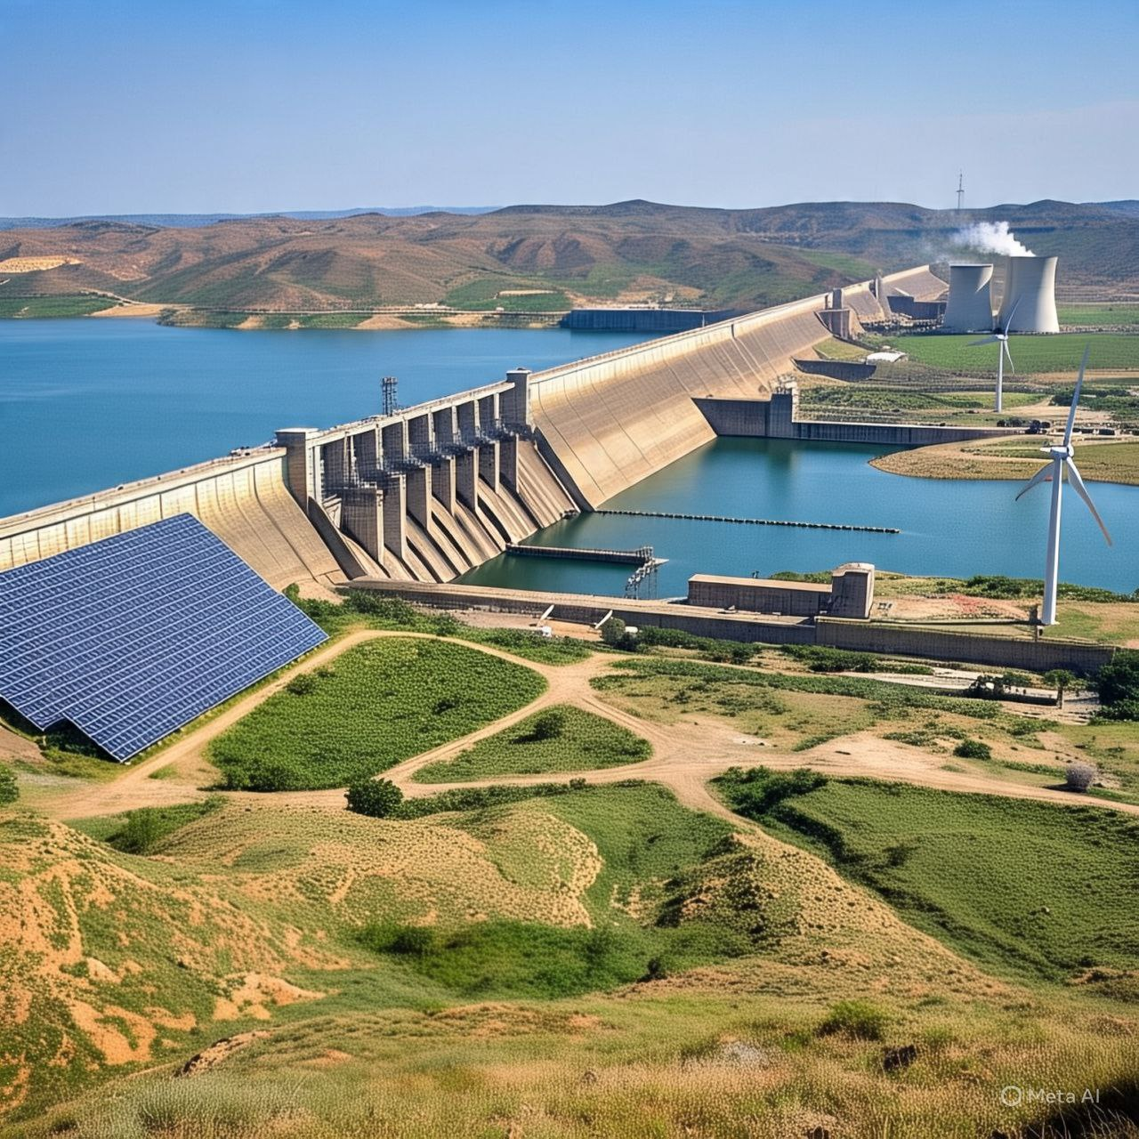

# **INTRODUCTION**

Energy production is the process of generating power from various sources to meet the demands of modern society. The world’s energy needs are primarily met through different types of resources, which can be categorized into renewable and non-renewable sources. Non-renewable sources include fossil fuels like coal, oil, and natural gas, which have been the dominant sources of energy for centuries. However, these sources are finite, leading to the growing concern over environmental pollution, resource depletion, and climate change.

In contrast, renewable energy sources such as solar, wind, hydropower, and geothermal are becoming increasingly important due to their sustainability and minimal environmental impact. These sources are continuously replenished and offer a cleaner alternative to traditional fossil fuels. The shift towards renewable energy is not only necessary for environmental conservation but also for achieving energy security in the long term.

The production of energy involves various methods, including combustion, nuclear fission, and harnessing natural elements like wind and sunlight. Advancements in technology have allowed for more efficient and environmentally friendly ways of producing energy, making it an area of constant innovation .

* TYPES OF ENERGY:-

There are mainly two types of energy on the basis of uses:

3. Renewable Energy

Renewable energy refers to energy that is derived from natural resources that are constantly replenished, such as sunlight, wind, rain, tides, waves, and geothermal heat. Unlike fossil fuels, which are finite and contribute to environmental degradation and climate change, renewable energy sources are sustainable and emit little to no greenhouse gases during energy generation. Renewable energy is obtained from nature. A few examples of renewable energy sources are:

1. Solar Energy:-

Solar energy is a renewable and sustainable form of power derived from the radiant energy of the sun. This [energy](https://www.geeksforgeeks.org/what-is-energy/) is harnessed through various technologies, primarily through photovoltaic cells and solar thermal systems. Photovoltaic cells commonly known as solar panels, convert sunlight directly into electricity by utilizing the photoelectric effect. The Bhadla Solar Park is a [solar power plant](https://en.wikipedia.org/wiki/Photovoltaic_power_station) located in the [Thar Desert](https://en.wikipedia.org/wiki/Thar_Desert) of [Rajasthan](https://en.wikipedia.org/wiki/Rajasthan), [India](https://en.wikipedia.org/wiki/India). It covers an area of 56 square kilometers and has a total installed capacity of 2,245 [megawatts](https://en.wikipedia.org/wiki/Watt) (MW), making it India's largest and the [11th-largest solar park in the world](https://en.wikipedia.org/wiki/List_of_photovoltaic_power_stations#World's_largest_photovoltaic_power_stations) as of 2024. The park was developed in four phases since 2015, with $775 million in funding from the [Climate Investment Fund](https://en.wikipedia.org/wiki/Climate_Investment_Funds) and $1.4 billion in funding from other sources. The park contributes to India's [renewable energy](https://en.wikipedia.org/wiki/Renewable_energy) goals and helps reduce [greenhouse gas emissions](https://en.wikipedia.org/wiki/Greenhouse_gas_emissions) by an estimated 4 million tons per year.

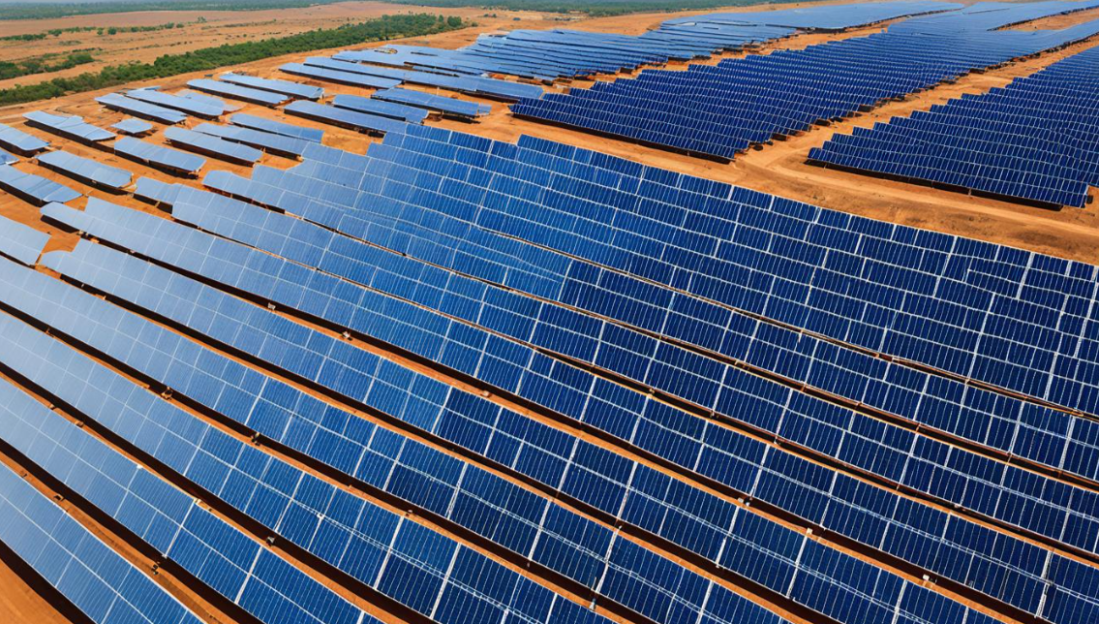 Image : A solar power plant courtesy: wikipedia

1. Wind Energy:-

Wind power is the use of [wind](https://en.wikipedia.org/wiki/Wind) energy to generate useful work. Historically, wind power was used by [sails](https://en.wikipedia.org/wiki/Sails), [windmills](https://en.wikipedia.org/wiki/Windmill) and [windpumps](https://en.wikipedia.org/wiki/Windpump" \o "Windpump), but today it is mostly used to generate [electricity](https://en.wikipedia.org/wiki/Electricity). This article deals only with wind power for electricity generation. Today, wind power is generated almost completely using [wind turbines](https://en.wikipedia.org/wiki/Wind_turbine), generally grouped into [wind farms](https://en.wikipedia.org/wiki/Wind_farms) and connected to the [electrical grid](https://en.wikipedia.org/wiki/Electrical_grid).

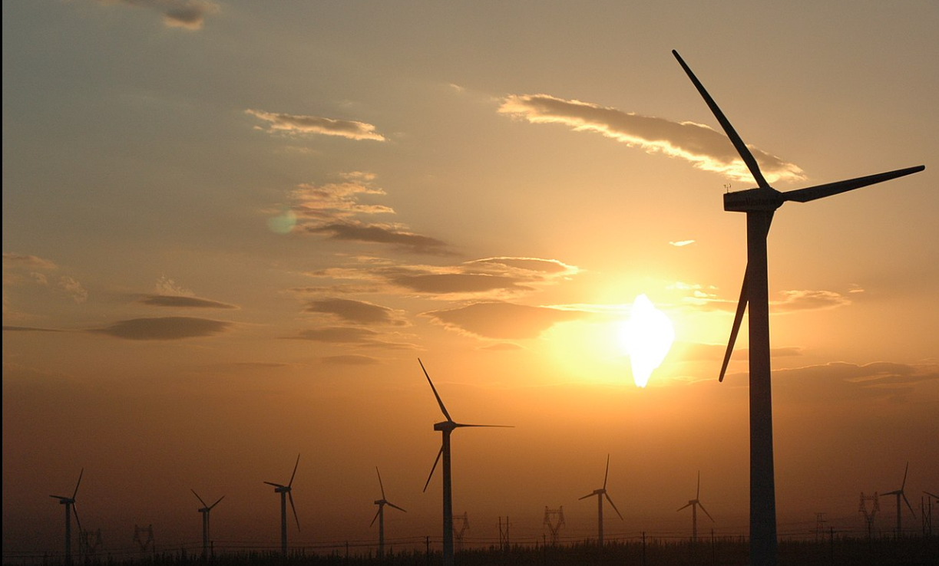

Image: A wind mills generating energy. Courtesy: Wikipedia

1. Hydropower Energy:-

Hydroelectric energy is the most widely used renewable power source on the planet. Hydroelectric energy means the production of electricity using hydropower as a power source. Hydroelectric energy is a traditional source of energy in which the kinetic energy of water flowing at high speed and the potential energy of the same water, which is made to run on the spillway of a dam, are used to generate electricity.

Hydropower plants make energy by utilising the power of water to turn turbines. A Hydropower plant works in the same way as a coal fuel plant. For instance, when coal is burnt in a coal plant, the steam that is produced powers turbines that generate electricity. With hydropower, the energy source that creates power is wate

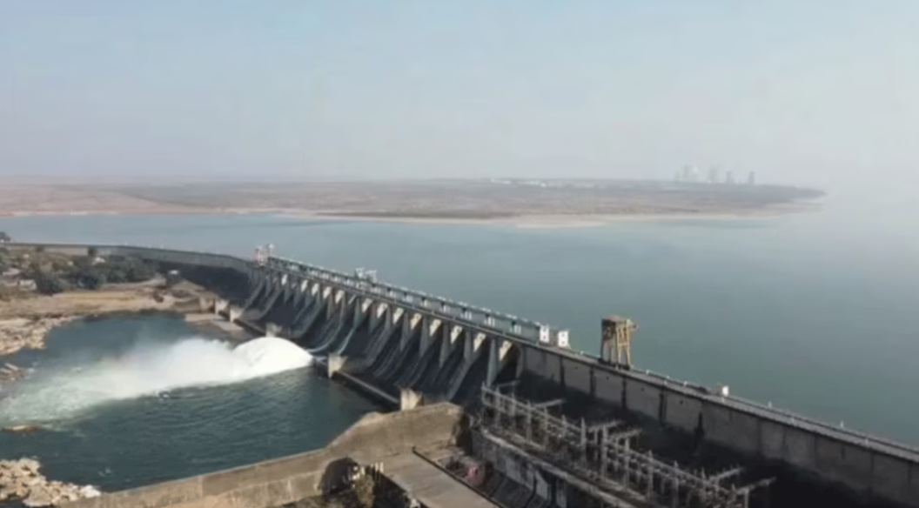

Image:Ranapratap sagar dam , Rajasthan . courtesy : Wikipedia

1. Biomass Energy**:-**

In the context of energy production, biomass is matter from recently living (but now dead) organisms which is used for [bioenergy](https://en.wikipedia.org/wiki/Bioenergy) production. Examples include wood, wood residues, [energy crops](https://en.wikipedia.org/wiki/Energy_crop), agricultural residues including [straw](https://en.wikipedia.org/wiki/Straw), and [organic waste](https://en.wikipedia.org/wiki/Biodegradable_waste) from industry and households.[[1]](https://en.wikipedia.org/wiki/Biomass_(energy)#cite_note-1) Wood and wood residues is the largest biomass energy source today. Wood can be used as a fuel directly or processed into [pellet fuel](https://en.wikipedia.org/wiki/Pellet_fuel) or other forms of fuels. Other plants can also be used as fuel, for instance [maize](https://en.wikipedia.org/wiki/Maize), [switchgrass](https://en.wikipedia.org/wiki/Switchgrass" \o "Switchgrass), [miscanthus](https://en.wikipedia.org/wiki/Miscanthus" \o "Miscanthus) and [bamboo](https://en.wikipedia.org/wiki/Bamboo).

1. Geothermal Energy:-

Geothermal energy is [thermal energy](https://en.wikipedia.org/wiki/Thermal_energy) extracted from the Earth's [crust](https://en.wikipedia.org/wiki/Crust_(geology)). It combines energy from the formation of the planet and from [radioactive decay](https://en.wikipedia.org/wiki/Radioactive_decay). Geothermal energy has been exploited as a source of heat and/or electric power for millennia.

[Geothermal heating](https://en.wikipedia.org/wiki/Geothermal_heating), using water from [hot springs](https://en.wikipedia.org/wiki/Hot_springs), for example, has been used for bathing since [Paleolithic](https://en.wikipedia.org/wiki/Paleolithic" \o "Paleolithic) times and for [space heating](https://en.wikipedia.org/wiki/Space_heating) since Roman times. [Geothermal power](https://en.wikipedia.org/wiki/Geothermal_power) (generation of electricity from geothermal energy), has been used since the 20th century. Unlike wind and solar energy, geothermal plants produce power at a constant rate, without regard to weather conditions. Geothermal resources are theoretically more than adequate to supply humanity's energy needs. Most extraction occurs in areas near [tectonic plate boundaries](https://en.wikipedia.org/wiki/Tectonic_plate_boundaries).

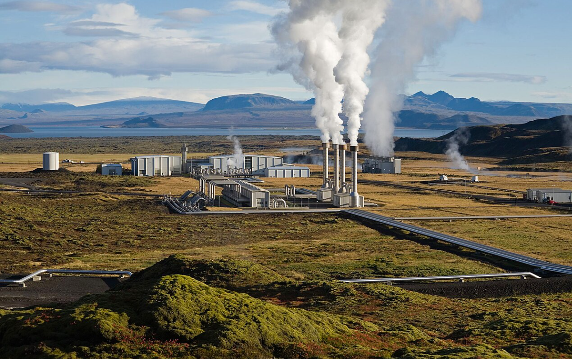

Image:  [Nesjavellir Geothermal Power Station](https://en.wikipedia.org/wiki/Nesjavellir_Geothermal_Power_Station" \o "Nesjavellir Geothermal Power Station) in [Iceland](https://en.wikipedia.org/wiki/Iceland) courtesy : Wikipedia

1. Non Renewable Energy:-

Non-renewable energy refers to energy sources that are finite and cannot be replenished within a human lifespan. These sources typically include fossil fuels like coal, oil, and natural gas, as well as nuclear energy derived from uranium. There are basically two types of non-renewable energy

1. Thermal Energy:-

* Fossil fuels, including coal, oil, and natural gas, are organic substances formed from the remains of prehistoric plants and animals buried deep underground over millions of years.
* They have been the primary sources of energy for human civilization for centuries, powering industries, transportation, and electricity generation.

1. Nuclear Energy:-

* Nuclear fuels, such as uranium and plutonium, are utilized in nuclear power plants to generate electricity through a process called nuclear fission.
* During fission, the nucleus of an atom is split, releasing a significant amount of energy. Nuclear power plants harness this energy to produce electricity on a large scale.
* USES OF ENERGY :-

Energy is used in various sectors to perform different functions, and its consumption varies widely depending on the nature of each sector. Here are the main sectors and how energy is used in each:

1. Residential Sector:

* Heating and Cooling: Energy is used for space heating and cooling, including the use of electric or gas-powered systems like furnaces, air conditioners, and heat pumps.
* Appliances: Energy is consumed by appliances like refrigerators, washing machines, dryers, dishwashers, and cooking equipment (e.g., ovens and stoves).

1. Commercial Sector:

* Heating, Ventilation, and Air Conditioning (HVAC): Like residential buildings, commercial buildings require energy for heating and cooling, but often on a larger scale.

1. Industrial Sector:

* Manufacturing: Energy is used in factories for machinery, production lines, and processes like smelting, forging, and chemical production.
* Raw Material Processing: Energy-intensive industries such as cement production, steelmaking, and refining use a significant amount of energy to process raw materials

1. Transportation Sector:

* Road Transport: Energy is used for personal cars, trucks, buses, and other vehicles, typically in the form of gasoline, diesel, or electric power.
* Rail Transport: Trains, including freight and passenger trains, consume significant energy, usually through diesel or electricity.
* Air Transport: Airplanes require a large amount of energy, usually in the form of jet fuel, for takeoff, flight, and landing.

1. Agriculture Sector:

* Farming Equipment: Tractors, plows, and other machinery used in planting, cultivating, and harvesting crops consume energy, often from diesel or electricity.

# **RESEARCH PROBLEM**

1. Introduction to Problem:-

India's rapidly growing economy and population have significantly increased the demand for energy. To meet this demand, it is crucial to ensure consistent and sufficient energy production. However, total energy production is influenced by several interrelated factors such as energy consumption, installed capacity, and the availability of natural resources like coal, lignite, and natural gas. Despite the importance of these variables, there is a lack of comprehensive statistical analysis that integrates them to understand their impact on total energy production. Moreover, accurate forecasting models are needed to support long-term energy planning and policy-making. This study aims to fill this gap by analyzing historical data and forecasting future trends using advanced statistical and time series techniques.

1. Problem to the Statement:-

**Forecasting of India’s total energy production, considering key factors such as energy consumption, installed capacity, and availability of coal, lignite, and natural gas, is essential for sustainable energy planning**. However, existing models inadequately integrate these variables, limiting the reliability of future production predictions.

# **RESEARCH METHODOLY**

1. Research Design:-

This study follows a quantitative, descriptive, and predictive research design aimed at analyzing historical energy production data and forecasting future trends in India. The research uses statistical tools such as descriptive statistics, correlation, multiple regression, and time series modeling (ARIMA) to understand and predict total energy production based on several key variables.

1. Statistical Techniques and Analytical Tools :-

Here we discuss the statistical tools in detail that’s are using in our project.

1. Descriptive statistics:-
2. Mean:-

The mean, or arithmetic average, is calculated by summing all the values in a dataset and dividing by the total number of values. It’s sensitive to outliers and is commonly used when the data is symmetrically distributed

$\overline{X}=\frac{\sum{x}}{n}$

where $n=Total no. of observastion$

$\sum{x}=Total$ of all observation

1. Median:-

The median is the middle value when the dataset is arranged in ascending or descending order. If there’s an even number of values, it’s the average of the two middle values. The median is robust to outliers and is often used when the data is skewed.

Median for odd data: $M={\left(\frac{n+1}{2}\right)}^{th}observation$

Median for even data : $M=\frac{{\left(\frac{n+1}{2}\right) }^{th }obs + {\left(\frac{n}{2}\right) }^{th}obs}{2}$

1. Skewness:-

Skewness can be defined as a statistical measure that describes the lack of symmetry or asymmetry in the probability distribution of a dataset. It quantifies the degree to which the data deviates from a perfectly symmetrical distribution, such as a [normal (bell-shaped) distribution](https://www.geeksforgeeks.org/normal-distribution-in-business-statistics/). Skewness is a valuable statistical term because it provides insight into the shape and nature of a dataset's distribution.

$$S_{K}=\frac{3(\overline{X}-M)}{σ}$$

where ${ S}_{K}=Skewness$

$\overline{X}=Mean$

$M$ =Median

$σ=Stanadard deviation$

1. Kurtosis:-

Kurtosis is a statistical measure that defines how heavily the tails of a distribution differ from the tails of a normal distribution. In other words, kurtosis identifies whether the tails of a given distribution contain extreme values

Kurt(x)=E $\left[{\left(\frac{X-μ}{σ}\right)}^{4}\right]$

Where μ=E(X)

$σ=Stanadard deviation$

1. Correlation:-

Correlation helps identify patterns or trends between two variables. A positive correlation means both variables increase together, while a negative correlation means one increases as the other decreases. Common methods to measure correlation include Pearson’s r, Spearman’s rank, and Kendall’s tau. It's widely used in finance, science, and social research.

1. Karl Pearson Correlation:-

Karl Pearson's correlation coefficient, often denoted as r, is a measure of the linear relationship between two continuous variables. It was developed by Karl Pearson in the early 20th century and is one of the most widely used methods of correlation.

$$r=\frac{cov\left(x,y\right)}{σ_{x}.σ_{y}}$$

where $cov\left(x,y\right)=covraince between x and y$

$σ_{x}=standard deviation of x$

$σ_{y}=standard deviation of y$

1. Multiple Linear Regression:-

Multiple linear regression analysis is essentially similar to the simple linear model, with the exception that multiple independent variables are used in the model. The mathematical representation of multiple linear regression is:

**Y = a + b*X1* + c*X2*+ d*X3* + ϵ**

Where:

* **Y** – Dependent variable
* **X1, X2, X3**– Independent (explanatory) variables
* **a** – Intercept
* **b, c, d** – Slopes
* **ϵ** – Residual (error)

**Regression Analysis – Linear Model Assumptions**

Linear regression analysis is based on six fundamental assumptions:

1. The dependent and independent variables show a linear relationship between the slope and the intercept.
2. The independent variable is not random.
3. The value of the residual (error) is zero.
4. The value of the residual (error) is constant across all observations.
5. The value of the residual (error) is not correlated across all observations.
6. The residual (error) values follow the normal distribution.

Table 1:Description and Type of variables

|  |  |  |
| --- | --- | --- |
| Variable | Type | Description |
| Total energy production | Dependent | Amount of energy produced |
| Total energy consumption | Independent | Amount of energy consumed |
| Total installed capacity | Independent | Installed energy generation capacity |
| Availability of coal | Independent | Coal availability for energy production |
| Availability of lignite | Independent | lignite availability for energy production |
| Availability of crude oil | Independent | Crude oil availability for energy production |
| Availability of natural gas | Independent | Natural gas availability for energy prod. |

1. ARIMA Model:-

The ARIMA model, which stands for AutoRegressive Integrated Moving Average, is a popular time series forecasting method used when data shows trends but not clear seasonality. It combines three key components: AR (AutoRegressive), which relies on past values to predict future ones; I (Integrated), which involves differencing the data to make it stationary (removing trends); and MA (Moving Average), which accounts for past prediction errors to correct future forecasts. The general equation for ARIMA(p, d, q) is:

$$Y_{t}= ∑​∅_{i}​Y_{t-i}+ ∑​θj​∈_{t-j} ​+ ∈_{t}$$

Where:

$Y_{t}$ is the value at time t

$∅_{i}$ are the parameters for the autoregressive part (AR),

$θ_{j}$ are the parameters for the moving average part (MA),

$∈_{t}​$ represents the random error or residual at time t

* Steps For Fitting ARIMA Model:

1. Stationarity Testing:

Energy production time series data will be tested for stationarity using:

* Augmented Dickey-Fuller (ADF) test

If non-stationary, differencing will be applied to make the series stationary.

1. Model Identification:

The order of the ARIMA model (p, d, q) will be identified based on:

* Autocorrelation Function (ACF)
* Partial Autocorrelation Function (PACF)

1. Model Estimation and Diagnostics**:**

The ARIMA model will be fitted to the stationary time series data. Model diagnostics will be performed by examining:

* Residuals for randomness
* Ljung-Box test for autocorrelation in residuals
* Akaike Information Criterion (AIC) and Bayesian Information Criterion (BIC) for model selection

1. Forecasting:

Once validated, the ARIMA model will be used to forecast future total energy production for a defined horizon (e.g., next 5-10 years).

# **ANALYSIS AND INTERPRETATION**

* Descriptive Statistics:-

Here we describe the descriptive statistics of different variable related to energy production:

Table 2: Shows Descriptive Statistics of Different variable

|  |  |  |  |  |  |
| --- | --- | --- | --- | --- | --- |
| Variable | MEAN | MEDIAN | STANDARD  DEVIATION | SKEW. | KURTOSIS |
| Total energy production | 1137.2 | 1136.8 | 321.0 | 0.1940 | -1.0056 |
| Total energy consumption | 27874.5 | 28758. | 5579.2 | -0.0302 | -0.6908 |
| Total installed capacity | 282.08 | 291.1 | 104.3 | -0.0976 | -1.4792 |
| Availability of coal | 803.1 | 838.5 | 216.3 | 0.2894 | -0.6354 |
| Availability of lignite | 41.4 | 42.7 | 5.6 | -0.5208 | -1.0689 |
| Availability of crude oil | 222.8 | 226.9 | 37.2 | -0.8712 | -0.2048 |
| Availability of natural gas | 55.5 | 57.9 | 8.6 | -0.9323 | 0.0676 |

* Total Energy Production: Slightly positively skewed with a flat distribution, indicating fairly symmetrical values.
* Total Energy Consumption: Nearly symmetrical and moderately flat, showing stable consumption levels.
* Total Installed Capacity: Almost symmetrical with low peakedness, reflecting consistent capacity growth.
* Availability of Coal: Mildly positively skewed with fewer extreme values.
* Availability of Lignite: Moderately negatively skewed and flat, indicating higher frequency of large values.
* Availability of Crude Oil: Moderately negatively skewed with near-normal spread.
* Availability of Natural Gas: Moderately negatively skewed with a near-normal distribution

2.Correlation:-

Here we find correlation between total energy production and total energy consumption , installed capacity and resources like coal, natural gas ,crude oil and lignite.

Table 3: Shows Correlation B/w Different Variable

|  |  |  |
| --- | --- | --- |
| Variable 1 | Variable 2 | correlation |
| Total Energy production | Total consumption | 0.9864 |
| Total Energy production | Total Installed capacity | 0.9889 |
| Total Energy production | Availability of coal | 0.9881 |
| Total Energy production | Availability of lignite | 0.5624 |
| Total Energy production | Availability of natural gas | 0.8924 |
| Total Energy production | Availability of crude oil | 0.7427 |

* There is a very strong positive correlation (r = 0.9864) between total energy production and total energy consumption, indicating that as energy consumption increases, energy production also increases almost proportionally.
* There is a very strong positive correlation (r = 0.9889) between total energy production and total installed capacity, suggesting that higher installed capacity significantly contributes to increased energy production.
* There is a very strong positive correlation (r = 0.9881) between total energy production and the availability of coal, indicating that as coal availability increases, energy production also increases almost proportionally.
* There is a strong positive correlation (r = 0.8924) between total energy production and the availability of natural gas, suggesting that greater natural gas availability significantly boosts energy production.
* There is a moderate to strong positive correlation (r = 0.7427) between total energy production and the availability of crude oil, showing that crude oil availability has a considerable impact on energy production.
* There is a moderate positive correlation (r = 0.5624) between total energy production and the availability of lignite, meaning that increased lignite availability somewhat contributes to higher energy production, but the effect is weaker compared to coal and natural gas.
* Multiple Linear Regression Analysis:-

Here we construct a multiple regression model b/w total energy and consumption, installed energy and availability of resources.

Let $X_{1}$ = Total energy(BU)

$X_{2}=$ consumption of energy(Petajoules)

$X_{3}$ =total installed capacity(GW)

$X_{4}$ =availability of coal(Million tone)

$X_{5}$ =availability of lignite (Million tone)

$X_{6}$ =availability of crude oil(Millon tone)

$X_{7}$ =availability of natural gas(million metric cubic)

a= intercept

b, c, d, e, f, g slopes

**ϵ** – Residual (error)

1. Assumption Verification:-
2. Durbin-Watson Test for **autocorrelation** in residuals:

statistic = 1.759

p-value = 0.3657

So There is no evidence of autocorrelation in the residuals since p >=0.05.

1. Shapiro-Wilk Test for **normality of residuals**:

W =0.9689498,

p-value = 0.7777233

So Residuals are normally distributed p >= 0.05

1. Breusch-Pagan Test for **heteroscedasticity**:

BP = 7.091955,

p-value = 0.312

No evidence of heteroscedasticity since p >= 0.05

1. **Multicollinearity** :-

VIF factor of consumption( 96.54) is very high and creating multicollinearity so we remove this variable from our model for best fit.

1. Model Fitting :-

Using data from appendix A and B , and with the help IBM SPSS Statistical software we generate following model

**Model summary:**

Table 4: Shows model summary of fitted MLR model

|  |  |  |  |  |  |
| --- | --- | --- | --- | --- | --- |
| Predictor | Coef. | Estimate | Standard Error | T statistic | p-value |
| Constant | a | 87.58 | 79.32 | 1.104 | .291 |
| installed capacity | c | 1.703 | .318 | 5.359 | .000 |
| Coal | d | 0.754 | .158 | 4.766 | .000 |
| Lignite | e | 2.279 | 2.639 | .864 | .405 |
| crude oil | f | -1.344 | .845 | -1.591 | 1.38 |
| natural gas | g | 3.031 | 1.566 | 1.936 | .077 |

**Model diagnostics:**

Table 5:Shows model diagnostic of fitted MLR model

|  |  |
| --- | --- |
| R-Squared: | 0.997 |
| Adjusted R-Squared: | 0.994 |
| Overall F-statistic: | 382.707 |
| Overall p-value: | .000 |

The regression model is given as :

$X_{1}$**=87.85+ 1.73 $X_{3}$*+ + 0.754 $X_{4}$* + 2.279 $X_{5}$*– 1.34 $X_{6}$*+ + 1.566 $X_{7}$* + ϵ**

Due to high multicollinearity (VIF = 96.54), energy consumption was removed from the model to improve accuracy and avoid redundancy.

The refined regression model includes predictors: installed capacity, coal, lignite, crude oil, and natural gas.

* Installed Capacity (p = 0.000) and Coal (p = 0.000) are highly significant, showing strong positive effects on energy production.
* Lignite (p = 0.405) and Crude Oil (p = 1.38) are statistically insignificant, suggesting weak or no impact.
* Natural Gas (p = 0.077) is marginally significant, indicating a moderate influence.

The model has a very high explanatory power, with R² = 0.997 and Adjusted R² = 0.994, meaning 99.7% of the variance in total energy production is explained by the included variables.

The overall model is statistically significant (F = 382.707, p < 0.001), indicating that the regression equation fits the data well

* ARIMA Model :-

This analysis aims to forecast the total production of energy over the next five years using time series forecasting. The steps we will follow in the process include checking the stationarity of the data, applying the appropriate differencing method if necessary, and utilizing the ARIMA model for forecasting.

1. Stationarity Test:-

The first step in time series forecasting is to ensure that the data is stationary. A stationary series has properties like constant mean, variance, and autocorrelation over time. Non-stationary data can lead to misleading predictions and incorrect models.

To check the stationarity of the data, we use the Dickey-Fuller test (ADF Test). The results of the Dickey-Fuller test on the total energy production data from appendix A of total energy production since 2006-07 to 2022-23 are as follows:

* ADF Statistic: -0.2994
* p-value: 0.9255

Interpretation:

* The p-value is significantly higher than 0.05 (the level of significance), indicating that the data is non-stationary.
  + Since the data is non-stationary, we need to apply differencing to make it stationary.

1. Differencing to Achieve Stationarity:-

**First Order Differencing:-**

We first apply first-order differencing to the data. The purpose of this transformation is to subtract the previous data point from the current data point:

* ADF Statistic (First Order Differenced): -2.3353
* p-value: 0.16081

Interpretation:

* The p-value is still greater than 0.05, indicating that the series remains non-stationary even after first-order differencing.
* Therefore, we proceed to second-order differencing.

**Second Order Differencing:-**

Next, we apply second-order differencing to the data. This is done by subtracting the first-order differenced data from the previous first-order differenced data:

* ADF Statistic (Second Order Differenced): -3.5576
* p-value: 0.0066

Interpretation:

* The p-value is now less than 0.05, indicating that the data is now stationary after second-order differencing.

Since we have transformed the data to be stationary, we can now proceed with forecasting.

1. Model Identification: ARIMA

The next step in the forecasting process is to identify the appropriate ARIMA (AutoRegressive Integrated Moving Average) model. To determine the values of the AR (AutoRegressive) and MA (Moving Average) components, we examine the Autocorrelation Function (ACF) and Partial Autocorrelation Function (PACF) plots.

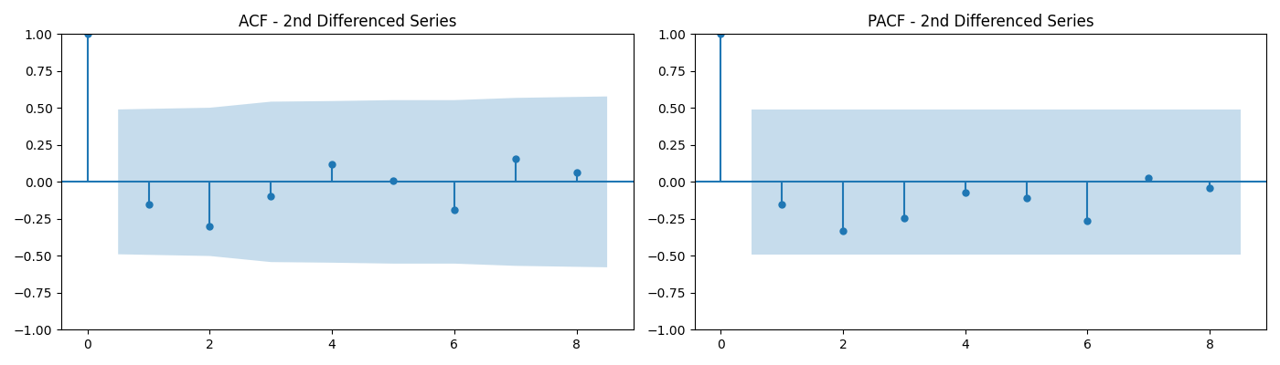Figure 2 : Shows the ACF and PACF plot

Upon plotting the ACF and PACF, we observe that the cutoff region for both ACF and PACF is at lag 0. This implies that:

* p (AR order) = 0 (since there is no significant lag in the PACF plot)
* q (MA order) = 0 (since there is no significant lag in the ACF plot)
* d (Differencing order) = 2 (since we performed second-order differencing)

Thus, we choose the ARIMA(0, 2, 0) model for forecasting.

1. Model Fitting:-

We now fit the **ARIMA(0, 2, 0)** model to the data. Since both the AR (p) and MA (q) components are zero, this model primarily involves differencing the data twice.

**Model Summary:**

Since p and q are zero, the model does not include any AR or MA terms. The coefficients and other statistics related to AR and MA terms are omitted.

Table 6: Shows model summary for fitted ARIMA(0,2,0) model

|  |  |
| --- | --- |
| Parameters | coefficients |
| AR(0) | No coefficients Involved(since order is zero) |
| MA(0) | No coefficients Involved(since order is zero) |

### 

|  |  |  |  |  |  |  |  |  |  |  |  |  |  |  |  |  |  |  |  |  |
| --- | --- | --- | --- | --- | --- | --- | --- | --- | --- | --- | --- | --- | --- | --- | --- | --- | --- | --- | --- | --- |
| **Model Diagnostics:-**  After fitting the model, we evaluate the residuals to check if they exhibit any issues. The residuals should resemble white noise — meaning they should be normally distributed, uncorrelated, and homoscedastic.  The following diagnostic tests were conducted:  Table 7: Shows model diagnostics of fitted ARIMA(0,2,0) Model   |  |  |  |  | | --- | --- | --- | --- | | Test | Statistics | P value | Summary | | Ljung-Box (Q) (L1) | 0.46 | 0.50 | Residuals are not autocorrelated (p >0.05) | | Jarque-Bera (JB) | 8.36 | 0.78 | Residuals are normally distributed (p >0.05). | | Heteroskedasticity | 3.64 | 0.18 | There is no heteroskedasticity (p > 0.05) | |  |  |  |  |

|  |  |  |  |  |  |  |  |  |  |  |
| --- | --- | --- | --- | --- | --- | --- | --- | --- | --- | --- |
| 1. Model Equation:-   The first difference of the series $Y_{t}$ is defined as: $$ΔY_{t}=Y_{t}​-Y_{t-1}​$$ The second difference is then: $$∆^{2}Y_{t}=Y_{t}​-2Y_{t-1}​+y_{t-2}​$$ Since there are no AR or MA terms in this model, the equation is simply  related to the second difference of the time series. Thus, the model  equation is: $$∆^{2}Y_{t}=∈_{t}$$ $$Y_{t}​-2Y_{t-1}​+y_{t-2}​=∈_{t}$$ So final equation is: | | | | | | |  |  |  |  |
|  | | | | | | |  |  |  |  |
|  | | | | | | |  |  |  |  |
| 1. Actual and Estimated Values Of Fitted Model:- | | | | | | |  |  |  |  |
| The graph below compares the actual and fitted values of total energy production. The fitted values closely follow the actual values, indicating that the model has successfully captured the underlying trend and behaviour of the energy production time series. |  |  |  |  |

Figure 3: Shows Data of actual and fitted for ARIMA(0,2,0) Model

Table 8: Shows Data of actual and fitted for ARIMA(0,2,0) Model since 2006-07

|  |  |  |  |  |  |  |  |  |  |
| --- | --- | --- | --- | --- | --- | --- | --- | --- | --- |
| Year | 2006-07 | 2007-08 | 2008-09 | 2009-10 | 2010-11 | 2011-12 | 2012-13 | 2013-14 | 2014-15 |
| Actual | 670.75 | 722.65 | 741.16 | 799.85 | 844.74 | 922.45 | 964.48 | 1026.64 | 1105.38 |
| Forecasted | 0 | 1006.24 | 774.65 | 759.67 | 858.54 | 889.63 | 1000.16 | 1006.51 | 1088.80 |

|  |  |  |  |  |  |  |  |  |
| --- | --- | --- | --- | --- | --- | --- | --- | --- |
| Year | 2015-16 | 2016-17 | 2017-18 | 2018-19 | 2019-20 | 2020-21 | 2021-22 | 2022-23 |
| Actual | 1168.37 | 1236.08 | 1303.34 | 1371.68 | 1383.33 | 1373.09 | 1484.36 | 1617.58 |
| Forecasted | 1184.12 | 1231.36 | 1303.79 | 1370.60 | 1440.02 | 1394.98 | 1362.85 | 1595.63 |

1. Five Year Forecasting:-

Finally, based on the ARIMA(0, 2, 0) model, we forecast the total energy production for the next five years.

Figure 4:Shows forecasted total energy production from 2022-23 to2029-29

Table 9: Shows forecasted total energy production from 2022-23 to2029-29

|  |  |  |  |  |  |
| --- | --- | --- | --- | --- | --- |
| YEAR | 2024-25 | 2025-26 | 2026-27 | 2027-28 | 2028-29 |
| TOTA ENERGY PRODUCTION | 1850.66 | 1967.20 | 2083.74 | 2200.28 | 2316.82 |

# **CONCLUSION**

1. **Descriptive analysis**

Most variables are approximately symmetric or mildly skewed, with platykurtic distributions (less prone to extreme values). The data suggests stable and relatively consistent trends in energy metrics, with no severe outliers or extreme variability. The consumption is much higher than production, which could indicate reliance on imports or inefficient utilization. Negative skewness in fossil fuel availability (like crude oil and natural gas) may indicate a few years or instances of significantly higher availability that aren't the norm.

1. **Strong Correlation with Consumption and Capacity**

The analysis reveals that total energy production is strongly correlated with both total energy consumption and the total installed energy capacity. This highlights the importance of expanding infrastructure to meet rising energy demands.

1. **Key Role of Fuel Availability in Thermal Energy**

Thermal energy production shows a strong dependence on the availability of coal and natural gas, while lignite and crude oil exhibit moderate correlations. This indicates that the supply of key fuels significantly influences thermal energy output.

1. **Regression Insights on Influencing Factors**

Regression modelling confirms that installed capacity, along with the availability of coal and crude oil, are the most significant factors affecting total energy production. In contrast, lignite and natural gas have a minimal statistical impact on overall production levels.

1. **Forecasted Growth in Energy Production**

The projected figures suggest a steady increase in total energy production over the coming years, as shown below:

|  |  |  |  |  |  |
| --- | --- | --- | --- | --- | --- |
| YEAR | 2024-25 | 2025-26 | 2026-27 | 2027-28 | 2028-29 |
| FORECASTED(BU) | 1850.66 | 1967.20 | 2083.75 | 2200.28 | 2316.82 |

These forecasts indicate consistent growth, supported by planned capacity enhancements and stable fuel supply condition

# **APPENDICES**

Appendix A:-

Table 10: Data of last 18 years of total energy production in India.

|  |  |  |  |  |  |
| --- | --- | --- | --- | --- | --- |
| YEAR | Non -RE(RE-NEWABLE) ENERGY | | RE (RE-NEWABLE )ENERGY | | TOTAL  ENERGY  (BU) |
| THERMAL  ENERGY  (BU) | NUCLEAR  ENERGY  (BU) | LARGE  HYDRO  ENERGY  (BU) | RES*  (wind,solar,  Bio) ENERGY  (BU) |
| 2006-07 | 528.49 | 18.80 | 113.50 | 9.86 | 670.65 |
| 2007-08 | 560.07 | 16.95 | 120.38 | 25.21 | 722.65 |
| 2008-09 | 588.28 | 17.20 | 110.09 | 27.86 | 741.16 |
| 2009-10 | 640.20 | 18.63 | 104.05 | 36.94 | 799.85 |
| 2010-11 | 664.82 | 23.26 | 114.41 | 39.24 | 844.74 |
| 2011-12 | 708.42 | 28.28 | 130.51 | 51.22 | 922.45 |
| 2012-13 | 760.45 | 30.86 | 113.72 | 57.44 | 964.48 |
| 2013-14 | 792.05 | 32.22 | 134.84 | 59.61 | 1026.64 |
| 2014-15 | 878.32 | 35.10 | 129.24 | 61.78 | 1105.38 |
| 2015-16 | 943.79 | 37.41 | 121.38 | 65.78 | 1168.37 |
| 2016-17 | 994.22 | 37.92 | 122.38 | 81.86 | 1236.08 |
| 2017-18 | 1037.10 | 38.30 | 126.10 | 101.83 | 1303.34 |
| 2018-19 | 1072.22 | 37.81 | 134.89 | 126.75 | 1371.68 |
| 2019-20 | 1042.75 | 40.47 | 155.77 | 138.34 | 1383.33 |
| 2020-21 | 1032.51 | 43.03 | 150.30 | 147.25 | 1373.09 |
| 2021-22 | 1114.71 | 47.11 | 151.63 | 170.91 | 1484.36 |
| 2022-23 | 1206.15 | 45.83 | 162.10 | 203.55 | 1617.58 |
| 2023-24 | 1326.29 | 47.94 | 134.05 | 225.84 | 1734.12 |

NOTE:- RES* includes solar ,wind and bio energy production.

BU:- Billion Unit ;GW:- Gigawat

Appendix B:-

Table 11: Data on last 18 years on total energy consumption, total installed capacity and availability of different energy resources.

|  |  |  |  |  |  |  |
| --- | --- | --- | --- | --- | --- | --- |
| Year | Consumption  (Petajoules) | Installed  Capacity  (GW) | Availability of Resources | | | |
| Coal  (million  Tones) | Lignite  (million  Tones) | Crude oil  (million  Tones) | Natural Gas  (Billon metric Cube) |
| 2006-07 | 18463 | 132.32 | 482.37 | 31.76 | 145.49 | 37.60 |
| 2007-08 | 19616 | 143.06 | 507.68 | 33.31 | 155.79 | 39.80 |
| 2008-09 | 20915 | 147.96 | 550.68 | 33.00 | 166.28 | 40.90 |
| 2009-10 | 22034 | 159.38 | 620.39 | 33.73 | 195.95 | 56.65 |
| 2010-11 | 23556 | 173.62 | 604.53 | 37.38 | 201.28 | 62.75 |
| 2011-12 | 24861 | 199.87 | 642.64 | 42.77 | 209.82 | 60.77 |
| 2012-13 | 25556 | 223.34 | 680.14 | 46.89 | 222.66 | 53.82 |
| 2013-14 | 26822 | 271.73 | 722.90 | 44.64 | 227.03 | 52.37 |
| 2014-15 | 28453 | 275.90 | 829.60 | 49.58 | 226.90 | 51.30 |
| 2015-16 | 29063 | 306.33 | 847.58 | 45.48 | 239.79 | 52.51 |
| 2016-17 | 29713 | 328.15 | 857.64 | 47.32 | 249.94 | 55.70 |
| 2017-18 | 30966 | 345.63 | 868.23 | 46.98 | 256.12 | 59.17 |
| 2018-19 | 32712 | 357.87 | 958.36 | 42.69 | 260.70 | 60.79 |
| 2019-20 | 32548 | 371.34 | 1002.17 | 41.88 | 259.70 | 64.14 |
| 2020-21 | 29807 | 383.52 | 956.02 | 37.21 | 226.95 | 60.82 |
| 2021-22 | 33018 | 399.5 | 945.36 | 45.89 | 242.07 | 64.14 |
| 2022-23 | 35159 | 416.06 | 1145.27 | 43.18 | 261.91 | 59.95 |

Appendix C:-

Here is python code of fitting ARIMA(0,2,0) model .

import numpy as np

import pandas as pd

import matplotlib.pyplot as plt

from statsmodels.tsa.arima.model import ARIMA

from statsmodels.tsa.stattools import adfuller

# Given time series data

data = [670.65, 722.65, 741.16, 799.85, 844.74, 922.45, 964.48, 1026.64, 1105.38,

1168.37, 1236.08, 1303.34, 1371.68, 1383.33, 1373.09, 1484.36, 1617.58, 1734.12]

# Convert the list to a pandas Series

series = pd.Series(data)

# Step 1: First differencing (d=1)

diff1 = series.diff().dropna()

# Step 2: Second differencing (d=2)

diff2 = diff1.diff().dropna()

# Check stationarity with Dickey-Fuller test on second differenced data

adf_result = adfuller(diff2)

print(f"ADF Statistic: {adf_result[0]}")

print(f"p-value: {adf_result[1]}")

# Step 3: Fit ARIMA(0, 2, 0) model

model = ARIMA(series, order=(0, 2, 0))

model_fitted = model.fit()

# Model summary

print(model_fitted.summary())

# Step 4: Diagnostic plots

model_fitted.plot_diagnostics(figsize=(10, 8))

plt.show()

# Step 5: Forecast the next 5 values

forecast = model_fitted.forecast(steps=5)

print("Forecasted Values for Next 5 Periods:")

print(forecast)

# Step 6: Get the fitted values (estimated values)

fitted_values = model_fitted.fittedvalues

# Step 7: Plot actual vs. fitted values

plt.figure(figsize=(10,6))

plt.plot(series, label="Actual Values", color='blue')

plt.plot(fitted_values, label="Fitted Values", color='red', linestyle='--')

plt.title("Actual vs Fitted Values for Energy Production")

plt.xlabel("Time Period")

plt.ylabel("Energy Production")

plt.legend()

plt.show()

# **REFERENCES**

1. [Mospi.gov.in/publication/energy-statistics-india-20235](https://mospi.gov.in/publication/energy-statistics-india-2025) (site of Ministry of Statistics and Programme Implementation)
2. [Renewable Energy Statistics 2022-23| MINISTRY OF NEW AND RENEWABLE ENERGY | India](https://mnre.gov.in/en/renewable-energy-statistics/)
   1. [Statistical Year Book India 2018 | Ministry of Statistics and Program Implementation | Government Of India](https://mospi.gov.in/statistical-year-book-india/2018)
3. [Bilgen et al., 2004](https://www.sciencedirect.com/science/article/pii/S2949753122000066#bbib19),S. Bilgen, K. Kaygusuz, A. Sari: Renewable energy for a clean and sustainable future
4. Halkos, G. E., & Gkampoura, E. C. (2020). Reviewing usage, potentials, and limitations of renewable energy sources. Energies, 13(11), 2906.
5. Ghiasi, M., Esmaeilnamazi, S., Ghiasi, R., & Fathi, M. (2020). Role of renewable energy sources in evaluating technical and economic efficiency of power quality. Technology and Economics of Smart Grids and Sustainable Energy, 5(1), 1-13.
6. Husin, H., & Zaki, M. (2021). A critical review of the integration of renewable energy sources with various technologies. Protection and Control of Modern Power Systems, 6(1), 1-18.
7. Rohan Kandpal II and Rajendra Singh 2022 ECS Trans. 107 8133: Renewable Energy Sources – A Review
8. The potential of India’s Renewable energy 2012 report by Gyan Research and Analytics Pvt. Ltd.
9. Energy Resources and India’s Security 2009 Report by Teri , The Energy and Resource Institute.
10. Overview of Renewable Energy Potential of India, 2006, Global Energy Network Institute